Updating Hopper Gauge

- Plug in updater to power to allow it to boot up
Once Powered on you should have a Green Power light
Unit is ready to Program once you have a flashing Green Stat light (take about 40 Sec)
- Remove Reabe hopper gauge main display from aircraft.
- Remove rubber boot over dim button and (4) Screws from back of unit.
- Hold the unit by the sides of the Case and push on the Dim button to slide contents out of case.
- Connect Adapter Cable to Hopper Gauge ISP Port
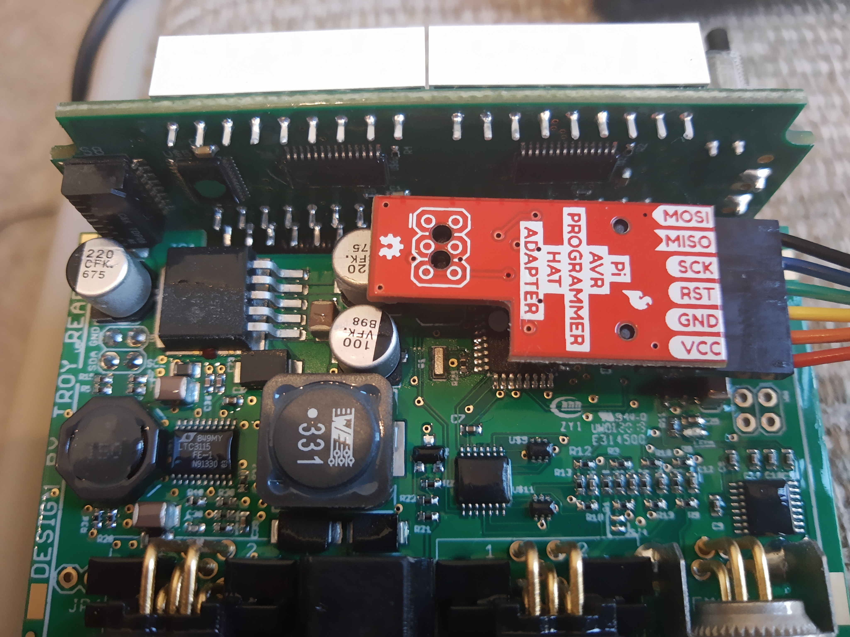
- Connect Power cord or tester board to Reabe Hopper Gauge Main Display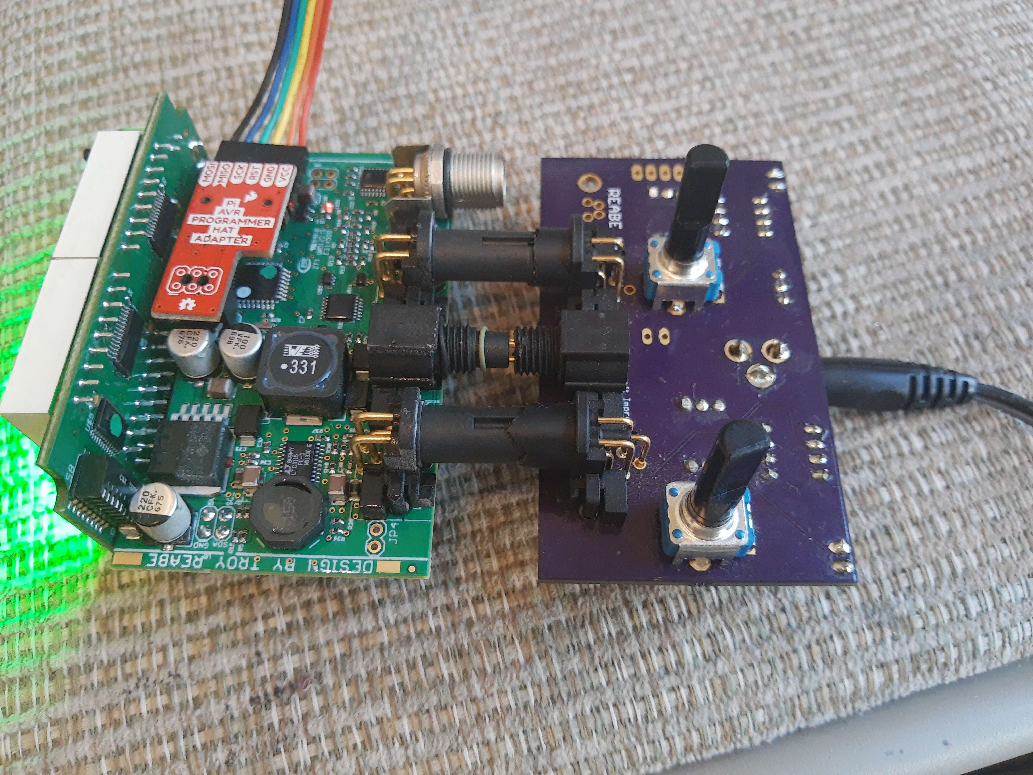
- Once Reabe Hopper Gauge Main Display is power up press the tap to program area of updater.
- Once Upload is complete you should have Green Success lights in “Flash Hex” and “Lock Bits”
- Remove Adapter cable and power cables from Reabe Hopper Gauge Main Display.
- Reinsert Reabe Hopper Gauge Main Display contents into case. Watch for dim Button in front of case.
- Reinstall 4 screws in back of case and Rubber boot over dim button.
- Reinstall unit into aircraft.
- Hold dim Button during unit power on to zero the boom pressure gauge.

